JavaServer Faces s a [Java](https://en.wikipedia.org/wiki/Java_(programming_language)) specification for building [component](https://en.wikipedia.org/wiki/Software_component)-based [user interfaces](https://en.wikipedia.org/wiki/User_interface) for [web applications](https://en.wikipedia.org/wiki/Web_application)[[1]](https://en.wikipedia.org/wiki/JavaServer_Faces#cite_note-1) and was formalized as a standard through the [Java Community Process](https://en.wikipedia.org/wiki/Java_Community_Process) being part of the [Java Platform, Enterprise Edition](https://en.wikipedia.org/wiki/Java_Platform,_Enterprise_Edition). It is also a [MVC](https://en.wikipedia.org/wiki/Model,_view,_controller) [web framework](https://en.wikipedia.org/wiki/Web_framework) that simplifies construction of [user interfaces](https://en.wikipedia.org/wiki/User_interface) (UI) for server-based applications by using reusable UI components in a page.[[2]](https://en.wikipedia.org/wiki/JavaServer_Faces#cite_note-2)

Database mySql

Welcome to JSF Database example. We will use JSF with MySQL database and use JDBC for our example. **Java Server Faces** can be connected to database to perform operations on the data using JDBC API.

https://www.journaldev.com/7068/jsf-database-example-mysql-jdbc

<https://wlu-residence.symplicity.com/index.php/pid861997>?

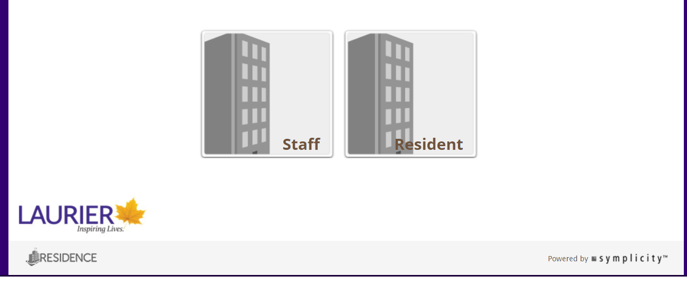

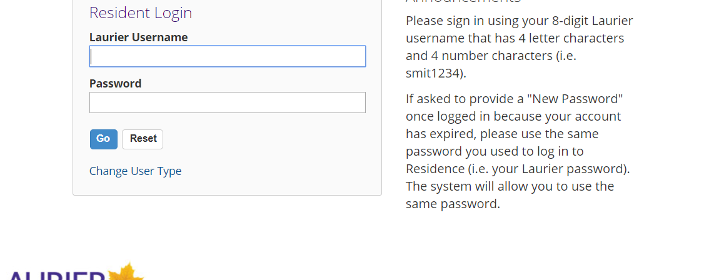

Residence Management System

**A . Executive Summary**

Residence Management System:

A website with focus on mobile usability where students are able to obtain information on housing such as residence halls, townhouses and apartments. Students should be able to register as well as use this tool to request room change and maintenance information. There will be a management side where an overview of students can be monitored and maintenance task can be scheduled/approved.

**B . Business Objectives**

1. *Business Need/ Opportunity/ Objectives* 
   * Lakehead  University currently does not have a Residence Management System. By implementing such system students will over all have a better experience finding out more information and registering for housing.
   * It provides a tool to monitor and manage students with ease.
   * Students/Residence may view there own information and request room changes and provide instant feedback improving overall experience

         Product Description (solution)

* + Solution Description : Providing a Residence Management System eases the process starting from finding information about housing to registration.
  + Students will have less concern about the overall process to register for residence. Improving experience while studying at Lakehead University.

**C . Functional Requirements:**

1. *User (Student)*
   * User should be able to find out on campus housing information detailed available rooms, cost and other information to help them decide what accommodation best suits them
   * User can provide feedback notes which can be viewed by management
   * User can request maintenance to fix or replace issues with room
   * User can update personal information
2. *Management* 
   * Can have over view of all student information ( Names , Housing type, Housing Number Etc)
   * Can view and approve new students for housing applications
   * Can add rooms, apartments and townhouses
   * Can approve maintenance request monitor for completion
   * Can remove students

**D . Deliverables:**